Name(s): ___Pamela Esprívalo Harrell_
Date/Time: 2 days (130 minutes)
Name of Course, Grade, and Level: __Biology I______

Science Topic | DNA Structure

Title of Lesson: Berry Full of DNA
Concept Statements:
- The genetic code is in DNA.
- DNA provides the template for DNA replication.
- Nucleotides are the building blocks of DNA.
- Enzymes facilitate the synthesis of DNA.

Source of Lesson:
Harrell, P. E. &Taylor, S.C. (2014). BIO 9 (C) Simply Outrageous Science.

List of appropriate TEKS: Chapter 112.34 Biology
TEKS # | Student Expectation
BIO 1 (A) | demonstrate safe practices during laboratory and field investigations
BIO 3 (E) | evaluate models according to their limitations in representing biological objects or events
BIO 5 (A) | describe the stages of the cell cycle, including deoxyribonucleic acid (DNA) replication and mitosis, and the importance of the cell cycle to the growth of organisms;
BIO 6 (A) | identify components of DNA, and describe how information for specifying the traits of an organism is carried in the DNA
BIO 6 (C) | explain the purpose and process of transcription and translation using models of DNA and RNA

 | Objectives | Evaluation Questions
1 | Recognize that traits are carried in DNA (central dogma). | Describe how genetic traits are carried in DNA.
2 | Identify the components of DNA. | What are the building blocks of DNA?  Describe the molecules that make up the building blocks of DNA.  Draw and label a DNA building block.
3 | Describe DNA replication. | List the four nitrogenous bases for DNA.  Describe DNA base pairing  Describe how nucleotides are linked together using hydrogen and covalent bonding.  Differentiate purines and pyrimidines  What is meant by the triplet code?  Describe semiconservative replication
4 | List and describe the role of enzymes in DNA synthesis and repair. | What is the function of DNA polymerase?  What is the function of DNA ligase?

Resources, Materials, Handouts, and Equipment List in the form of a table:
ITEM  (Specify worksheets) | Quantity  (How many do you need?) | Source  (Who is responsible? | List who this is for (teacher, student, group)
Strawberry DNA Extraction  Fresh strawberries  isopropyl alcohol (from freezer)  Cheese cloth  Extraction buffer  Funnel  50 mL graduate cylinder  50 mL test tube  Plastic pipet  Quart size Ziplock™ Freezer Bag  Blackline master – Berry Full of DNA | 2 per group  10 mL per group  30 cm. per group  10 mL per group  1 per group  1 per group  1 per group  1 per group  1 per student | teacher | student
Computer with an Internet connection  http://www.cellsalive.com/cell_cycle.htm  Blackline master – The Never Ending Cycle | 1 per student  1 per student | teacher  teacher | student  student
DNA Jewelry  Copper wire (28 gauge)  3 mm gold bead  3 mm clear bead  Gold Tubular beads (Long)  Red tubular beads (Short)  Blue Tubular beads (Long)  Green Tubular beads (Short)  Key chair or wire earring  Petri dishes or cups to hold beads  Scissors  Blackline master – DNA Jewelry: Making your DNA Model and DNA Jewelry Procedure | 86 cm per student  26 per student  26 per student  8 per student  8 per student  5 per student  5 per student  1 per student  6 per student  1 per group  1 per student | Teacher | student
DNA model kit  DNA demo model | 1 per student  1 | teacher  teacher | student  teacher
Photo 51 DVD  Photo 51 film guide | 1 per student  1 | teacher | student
5 E Lesson Plan for DNA | 1 | teacher | teacher
Presentation | 1 | teacher | teacher

Advanced Preparations:
- Copy Blackline masters for each learning experience.

- Place container of isopropyl alcohol in freezer overnight.

- Mix extraction buffer for Strawberry DNA lab. Mix together the following ingredients in a 150 mL beaker.

  - 90 mL of water
  - 10 mL of Dawn dish detergent
  - 1.23 mL (1/4 teaspoon) salt

- Purchase and organize all materials for DNA extraction and DNA Jewelry

- Reserve computers

Safety:
- Wear a splash apron throughout the entire lesson to protect clothing.

- Do not taste or eat any of the materials.

- Horseplay and improper use of chemicals and equipment in the lab will result in removal from lab.

- Notify teacher and clean up spill immediately.

- Dispose of materials in the designated waste container provided by the teacher.

5E Lesson Plan

Objective Statement: Students will describe the components, structure, synthesis, and function of DNA.

ENGAGEMENT Time : Minutes 5 minutes
What the Teacher Will Do | Probing/Eliciting Questions and Students Responses | What the Students Will Do
Share a few interesting facts.  Humans shed their entire epidermis (skin) every 15-30 days. Bloodhounds can track as few as 1 or 2 skin cells that belong to escaped prisoners, missing children or pets. They have 4 billion olfactory receptor cells compared to humans who have just 5 million.  More recently, small DNA samples can be analyzed using the Touch DNA which can analyze as few as 5-20 cells that might be left behind when one touches something such as clothing or a glass. | How do we replace our entire epidermis so quickly? Cells are constantly dividing to replace those that are worn out or damaged.  How many cells does a human shed each day. On average, a human lose 50 million cells every day.  http://askabiologist.asu.edu/content/cell-division | Students may provide comment and ask questions. However, however, questions that require a detailed response will be written down and saved for the debriefing activity.

Transition Statement
Before you litter the room with more of your skin cells and DNA that we can’t see, let’s take a look at some DNA from strawberries to see what it looks like.

EXPLORATION Time: 15 Minutes
What the Teacher Will Do | Probing/Eliciting Questions and Student Responses | What the Students Will Do
Prepare and organize the materials for the learning experience.  Instruct student group leaders to collect materials for strawberry DNA extraction as well as the blackline master, Berry Full of DNA Lab.  Review the lab safety protocol.  Ask students to read the lab protocol (1-2 minutes), then call on students to describe the steps necessary to complete the lab.  Monitor students and assist as required. Provide feedback as needed. | Why do we need to wear a splash apron today? To protect clothing from splashes.  What should you do in the event of a spill? Notify the teacher and clean up the spill.  When the lab is finished, what is done with the materials? They are disposed of in the container designated by the teacher.  Describe the properties of DNA Answers will vary but might include: white, amorphous, thread, looks like mucous. | Students will record narrative description of strawberry DNA and answer questions on the Blackline master, Berry Full of DNA.  Students will wear lab aprons to properly protect their clothing.  Students will dispose of all used chemicals properly and clean all equipment when they are finished with the experiment before moving on to the next experiment.
Transition Statement:
Now that we have investigated and collected evidence about the appearance of DNA, lets create some models to explore the structure of DNA on the molecular level.

EXPLANATION Time: 15 Minutes
What the Teacher Will Do | Probing/Eliciting Questions and Student Responses | What the Students Will Do
First, debrief students as you ask questions about the results of the experiment.  Second, ask students to record their observations on the board.or similar public place.  Provide a rationale for why learning about DNA is important. (1) forensic investigations; (2) determining paternity; (3) reuniting individuals separated during wars or other circumstances; (4) identifying risk for disease; (5) identifying genetic traits (e.g., hemophilia, tay sachs); and (6) drug therapy | Debrief students using the lab questions.  - How did the appearance of the strawberries change as you added the extraction buffer gently kneaded the bag? A whitish thread materials appeared.  - What do you think is happening in this step? The DNA (along with some proteins) is being removed from the strawberry.  - Describe the appearance of the mixture when you first began to place the ice-cold alcohol on the strawberries with buffer solution. It looked a lot like a strawberry shake.  - Describe what happened when you first twirled the stick in or near the DNA-alcohol interface. A white substance began to collect on the stick.  - When you lifted the stick out of the tube and a fiber of DNA following, did you think that this was a single molecule of DNA? Answers will vary Why? Why not?  - How would you describe the appearance of DNA to someone who has never seen it? Answers will vary, it was white, theady, slimy. | Students will answer questions and record information on the Blackline master using observations and inferences from the learning experience.  Students will share photos and/or scientific drawings as evidences on which to base their explanations about the physical appearance of DNA.

Transition Statement
Now that you understand a little about how DNA looks to the naked eye, we will specifically look at models for DNA structure on a molecular level.

ELABORATION Time: 80 Minutes
What the Teacher Will Do | Probing/Eliciting Questions and Student Responses | What the Students Will Do
Assemble DNA jewelry materials.  Make copies of the Blackline masters for DNA Jewlery.  Monitor students and assist as required. Provide just in time feedback.  The teacher will provide information about the role of DNA polymerase and DNA ligase in the synthesis and repair of DNA.  *Connect DNA and histone proteins so students do not go away with the idea that chromosomes consist only of DNA.  The teacher should also emphasize that DNA is intimately associated with histone proteins that function as spools around which the threadlike DNA is wrapped. The histone proteins and DNA function as the basic unit of DNA packaging in eukaryotes that are elegantly folded and eventually form a chromosome. | DNA Jewelry Questions.  - Name the four nitrogen bases for DNA? Adenine, Guanine, Cytosine, Thymine.  - Name the type of bonding that holds the nitrogen bases together. Why is this type of bonding important during DNA replication? Hydrogen bonding. This type of bonding is weak and facilitates the unwinding and synthesis of the DNA.  - To what structure are the nitrogen bases attached? Deoxyribose sugar.  - To which structures is the phosphate attached? The sugar.  - How does one identify the 5’ end? The 5’ end begins with a phosphate.  - Which end of the DNA molecule is the sense strand? Why is it called the sense strand? The 5’ end is the sense strand. This strand is the one that carries the ordered code for making proteins.  - List the molecules that make up the sides of the DNA ladder. phosphate and deoxyribose sugar. | The student will create a DNA jewelry model using the self-guided learning activity.  The students will make drawings to demonstrate their understanding of the DNA components and how they are assembled.  Students will participate in discussion and debriefing for the activity.

Transition Statement
Now that we have explored the molecular aspects of enzyme/substrate interactions, let’s summarize our knowledge.
Closure Statement
Today we studied the structure of DNA. Understanding the structure of DNA helps us understand the association between skin cancer UV radiation as well as our own genetics passed to us by our parents. As researches learn more about disease, our understanding of DNA guides the development of gene therapy and other practices that improve health and life.

EVALUATION Time: 15 Minutes
What the Teacher Will Do | Probing/Eliciting Questions | What the Students Will Do
Prepare the assessment questions on paper.  Provide each student with a DNA model kit.  Administer the assessment using typical test security precautions.  Evaluate the student’s model using rubric and provide feedback. | - After observing the extracted DNA and participating in a class discussion, the learner will document the observable characteristics of DNA in their journal. A grade of pass/fail will be given.  - Using the internet, students will complete a chart with the two main parts of the cell cycle. A grade of pass/fail will be given.  - Given a DNA model kit, students will construct a model of DNA with double-helical structure, nitrogenous bases correctly paired, alternating deoxyribose sugar and phosphate backbone, and hydrogen bonding correctly displayed scoring at least four out of five points on the rubric | Without assistance, the students will individually complete a DNA model.

DNA Model Rubric
0 points | 1 point | 2 points | 4 points | 5 points
Model is not helical, less than 5 nitrogen bases are correctly paired, less than 5 of the hydrogen bonds are accurately portrayed, and the sugar/phosphate backbone is incorrect | Model is helical, 5/9 nitrogen bases are correctly paired, 5/9 hydrogen bonding is accurately portrayed, and the sugar/phosphate backbone is correct. | Model is helical, 6/9 nitrogen bases are correctly paired, 6/9 hydrogen bonding is accurately portrayed, and the sugar/phosphate backbone is correct. | Model is helical, 7/9 nitrogen bases are correctly paired, 7/9 hydrogen bonding is accurately portrayed, and the sugar/ phosphate backbone is correct. | Model is helical, at least 8/9 nitrogen bases are correctly paired, 8/9 hydrogen bonding are accurate, and the sugar/phosphate backbone is correct.
Berry Full of DNA
Blackline Master
Berry Full of DNA Handout
Explore

Objective:
Describe characteristics of strawberry DNA.

Materials:
2-3 fresh or individually frozen strawberries
1 Ziploc® plastic freezer storage bag
10 mL DNA extraction buffer
1 Funnel
1 50 mL graduated cylinder or measuring cup
1 50 mL test tube
10 × 20 cm double-ply cheesecloth
10 mL ice cold isopropyl alcohol
1 plastic pipet
1 wooden skewer

Procedure:
- Place strawberries into the plastic freezer storage bag.
- Using a graduated cylinder or measuring cup, measure 10 mL of DNA extraction buffer.
- Pour DNA extraction buffer in the freezer storage bag with the strawberries.
- Close the storage baggy and gently kneed the strawberry. Be careful not to puncture the bag.
- Place the funnel into the test tube.
- Holding the cheesecloth over the funnel, gently pour a small amount of the strawberry/buffer solution into the cheesecloth and strain into the funnel.
- Repeat step 6 until the test tube is ½ full of strawberry buffer solution.
- Pipet ice cold isopropyl alcohol down the side of the test tube until the test tube is ¾ full of liquid. There should be a clear layer of alcohol sitting on top of the strawberry/buffer solution.
- Collect the DNA by gently swirling the wooden skewer in the alcohol layer.

Observations:
- How did the appearance of the strawberries change as you added the extraction buffer gently kneaded the bag?

- What do you think in happening in this step?

- Describe the appearance of the mixture when you first began to place the ice-cold alcohol on the strawberries with buffer solution.

- Describe what happened when you first twirled the stick in or near the DNA-alcohol interface.

- When you lifted the stick out of the tube and a fiber of DNA following, did you think that this was a single molecule of DNA? Why? Why not?

- How would you describe the appearance of DNA to someone who has never seen it?

Blackline Master
DNA Jewelry Handout
Elaboration
DNA Jewelry
Making Your DNA Molecule

Objective(s): Given a DNA model kit, you will construct a model of DNA with double-helical structure, nitrogenous bases correctly paired, alternating deoxyribose sugar and phosphate backbone, and hydrogen bonding correctly displayed scoring at least four out of five points on the rubric [see rubric].
Procedures:
Part I: Create a DNA molecule according to the directions given to you.
Part II: Decoding Your DNA Model in Table 1.

Table 1: DNA Jewelry Model
Shape and Color Key | Name | Model (Tape Model Here)
A | Adenine
T
G
C
D
P

Read your model from the top down, and use the strand that has the phosphate at the top as the sense strand. Color in the symbols with the colors that correspond to the color of the beads in your model. Then, based on your model, fill in the transcribed mRNA and the amino acids for which they code in the spaces on the next page. You may need to draw additional rungs on the ladder to correspond to the number of rungs in your model.
5’ 3’

“Sense” Strand “Non-Sense” Strand

3’ 5’

DNA Jewelry
Step One
- Measure out 34 inches / 86 centimeters of 28 gauge wire. Find the mid-point and place the beads in the following manner at the halfway point.
- During this and all following operations, be careful not to put "kinks" in the wire because that will weaken the wire and make it difficult to thread the wire through the narrow openings in the tubular bugle beads.
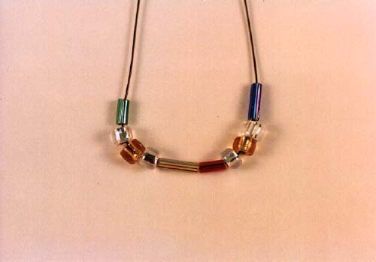

Step Two
- Run the end of the wire on the right, in the previous frame, through the green and silver bead on the left. Run the end of the wire on the left through the blue and silver bead on the right.
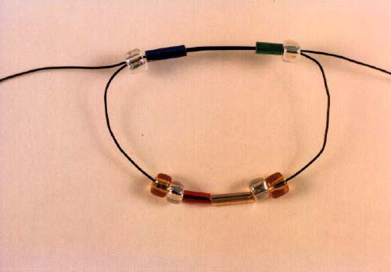

Step Three
- Double check that the beads are in the center of the wire. Pull the wires gently to snug up the beads against each other. They should look like the photo below.
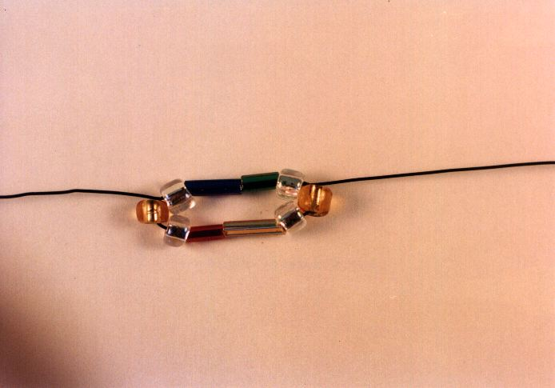

Step Four
- Add a gold (phosphate) and a silver (deoxyribose) to the right and left wires. Add your choice of one of the matching nitrogen bases to each wire. Remember that the purine adenine pairs with the pyrimidine thymine and the purine guanine pairs with the pyrimidine cytosine. Cross the wires, and gently remove the slack in the wire as you did before.
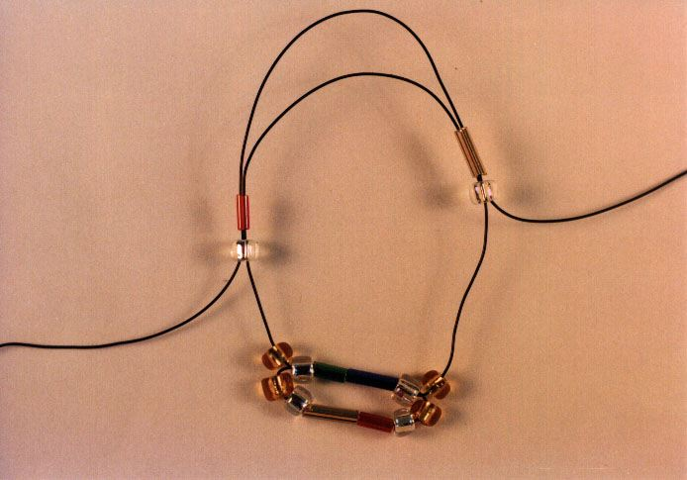

Step Five
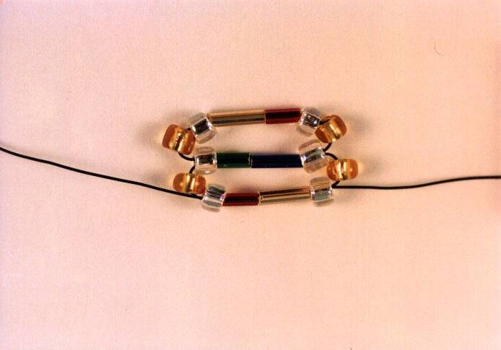 | 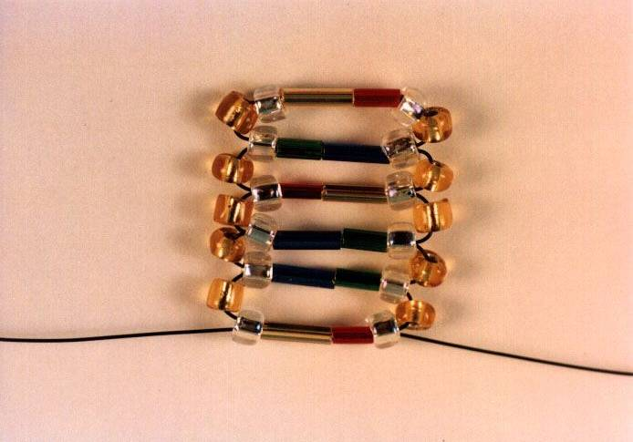
- Repeat the previous steps as many times as you wish. The sequences are up to you--DNA has an infinity of possible combinations of base pairs.

Step Six
- Keep the wire rather taut when you pull the gold colored phosphate seed beads out to the sides of the molecule. This is shown in the following photo.
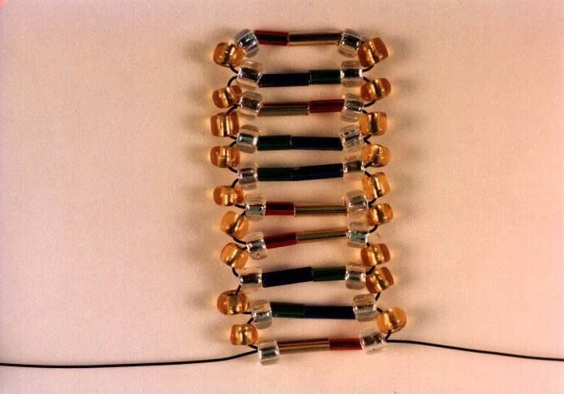

Step Seven
- Earrings can be made any length-- twelve base pairs make a nice single twist of the double helix. You can, of course, make other ornaments with this technique-- like Christmas tree decorations.

Step Eight
- When you place your last base pair onto your DNA molecule, allow a bit of wire to extend from between the last two base pairs. With a pair of pliers, or even a paperclip, form a small loop so you can later attach the ear hook.
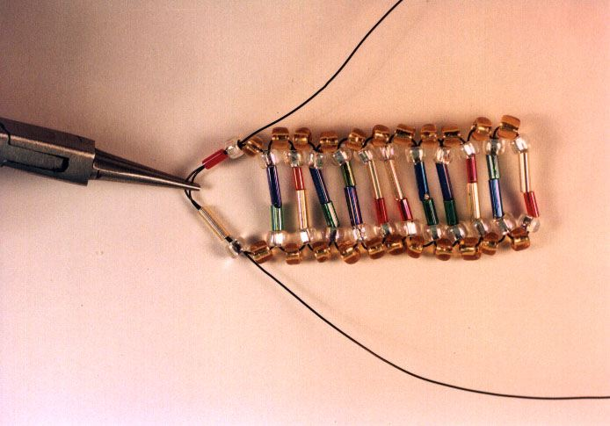

Step Nine
- Give the wire a little twist.
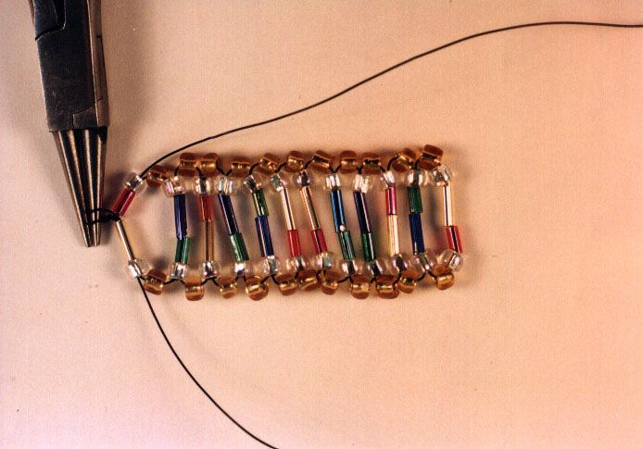

Step Ten
- The remaining wire should be threaded down through the gold phosphate seed beads... again be careful not to put "kinks" into the wire. The loops tend to kink as you pull the wire through at this point.
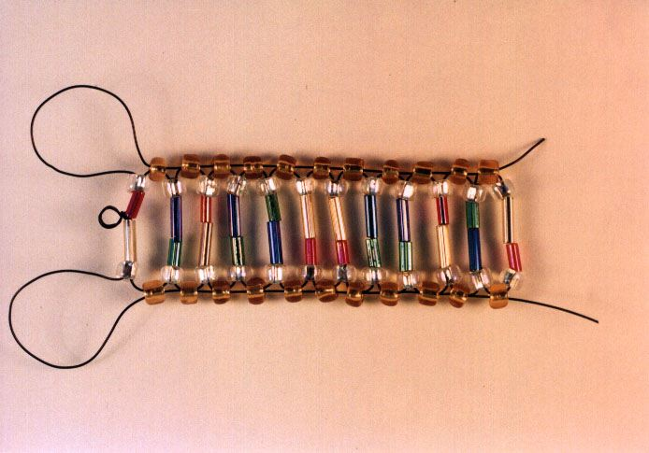

Step Eleven
- Cut the excess wire off at the bottom of the helix.
- If you want to make even more sturdy jewelry, you can cross the wires at the bottom and thread them up the opposite side. This technique makes a very strong helix, but the wire shows.
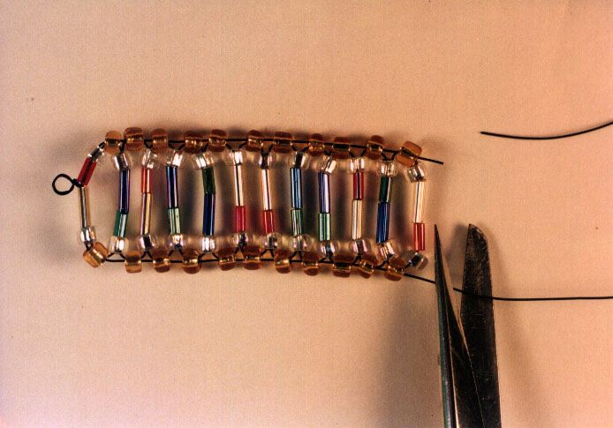

Step Twelve
- At this point, spend a few moments adjusting all of the beads in your helix. When all seem in their proper positions, give the "ladder" a little counter-clockwise twist.
- Add a keyring or add an ear attachment hook to the loop at the top and wear this beautiful symbol of life's main molecule.... or give it to someone who will!
