ALGEBRA 1 LESSON: WICKED GRAPHING WITH WIKKI STIX
Math Topic | Quadratic Functions

List of appropriate TEKS:
TEKS # | Student Expectation
1F | (1) Mathematical process standards. The student uses mathematical processes to acquire and demonstrate mathematical understanding. The student is expected to:  (F) analyze mathematical relationships to connect and communicate mathematical ideas
1G | (1) Mathematical process standards. The student uses mathematical processes to acquire and demonstrate mathematical understanding. The student is expected to:  (G) display, explain, and justify mathematical ideas and arguments using precise mathematical language in written or oral communication.
7C | (7) Quadratic functions and equations. The student applies the mathematical process standards when using graphs of quadratic functions and their related transformations to represent in multiple ways and determine, with and without technology, the solutions to equations. The student is expected to:  (C) determine the effects on the graph of the parent function f(x) = x² when f(x) is replaced by af(x), f(x) + d, f(x - c), f(bx) for specific values of a, b, c, and d.

 | Objectives | Evaluation Questions
1 | I will determine the effects on the graph of the parent function f(x) = x² when f(x) is replaced by af(x) | 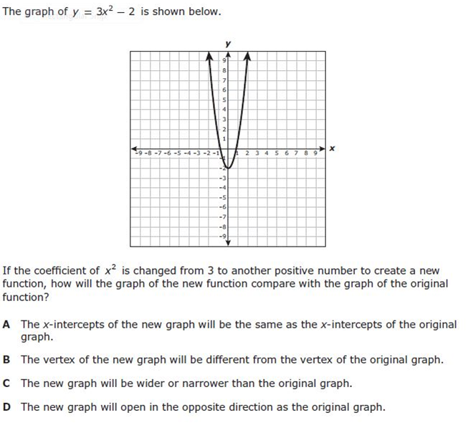
2 | I will determine the effects on the graph of the parent function f(x) = x² when f(x) is replaced by f(x) + d | What is the y-intercept of y=x²+6? How do you know?
3 | I will determine the effects on the graph of the parent function f(x) = x² when f(x) is replaced by f(x - c) | If the parent function f(x) = x² is changed to f(x) = (x-3)², what will happen to the new graph?

Resources, Materials, Handouts, and Equipment List in the form of a table: Example
ITEM  (Specify worksheets) | Quantity  (How many do you need?)
Quadratic Parent Function Graph Mat | 1 per student
Wikki Stix | 1 per student
Colored Pencils | 4 per student
ITEM  (Specify worksheets) | Quantity  (How many do you need?)
Graphing calculator | 1 per student

5E Lesson Plan
Objective Statement: Today we will be exploring transformations of quadratic functions. By the end of the lesson, we will be able to communicate the patterns we have discovered and determine the graph of various quadratic functions.
ENGAGEMENT Time : __5_Minutes
What the Teacher Will Do | Probing/Eliciting Questions and Students Responses | What the Students Will Do
1) Show the video clip.  “What happened in this scene?”  “What does that word mean, transform?”  “Let’s remember what we know about linear function transforming. Show me what the graph of y=x looks like with your pencil (or arms or ruler).”  Teacher will check for correct models.  “Now, model y= x+1”  Teacher will check for correct models.  “Now model y = -x”  Teacher will check for correct models. | “Please explain what happened to your graph?”  “Please explain what happened to your graph?” | Bumblebee transformed.  He changes. He changes shapes.  Students will model the graph of y= x.  Students should raise their pencils (arms/rulers) while keeping the same slope.  Students will model y=-x.
Transition Statement
Now that we have reviewed transformations of linear functions, we are going to explore transformations of quadratic functions.

EXPLORATION Time: 30 Minutes
What the Teacher Will Do | Probing/Eliciting Questions and Student Responses | What the Students Will Do
Assign partners. Each student will have their own graph mat, wikki stick, calculator, and investigation sheet. They will have multiple points in the investigation where they will communicate findings with a partner.  Have student leaders pass out materials.  Demonstrate #1 and #2 under a document camera. | . | Students will graph with wikki stix, graph with colored pencils, make and test conjectures, summarize the transformations they observe in words.
Transition Statement
“Let’s share out what we have observed about transformations of quadratic functions.”

EXPLANATION Time: 15 Minutes
What the Teacher Will Do | Probing/Eliciting Questions and Student Responses | What the Students Will Do
Call on students to share their responses to the questions in which they were asked to make generalizations.  Acknowledge all descriptions that correctly convey the transformation of the graph.  Introduce or restate academic vocabulary to describe the transformations such as horizontal shift, vertical shift, etc. | What is the difference between y=x²+3 and y= (x+3)²? | Students will share their observations and compare them with those of their classmates.  Students will take notes on vocabulary.
Transition Statement
Now that we have examined each type of transformation independently, let’s see how well you do when they are combined.

ELABORATION Time: 30 Minutes
What the Teacher Will Do | Probing/Eliciting Questions and Student Responses | What the Students Will Do
Display the following function.  y = 2x² +5  “Build this function with your wikki stick”  The teacher will project this website.  http://www.mathopenref.com/quadvertexexplorer.html  OR  https://www.desmos.com/calculator?tour=sliders  The teacher will call on a student to adjust the sliders.  Alternately, the teacher could display a calculator under a doc cam or on a smartboard and have a student enter the equation. | “Explain how you knew where to put the graph”  “What changes happened to the graph?”  “What is the vertex of this graph?”  “What is the axis of symmetry?” | Each student will build the function with the wikki stick on their graph mat.  Students will compare the graph they built with the wikki stick to the projected graph.
Transition Statement
Let’s summarize what we have learned today.
Closure Statement
Today, we have discovered how changing different parts of a quadratic equation affect the graph. Let’s check your individual knowledge with a quick quiz.

EVALUATION Time: 10 Minutes
What the Teacher Will Do | Probing/Eliciting Questions | What the Students Will Do
The teacher will instruct students to clear their desk for the evaluation. The teacher will state that the evaluation will be completed individually.

