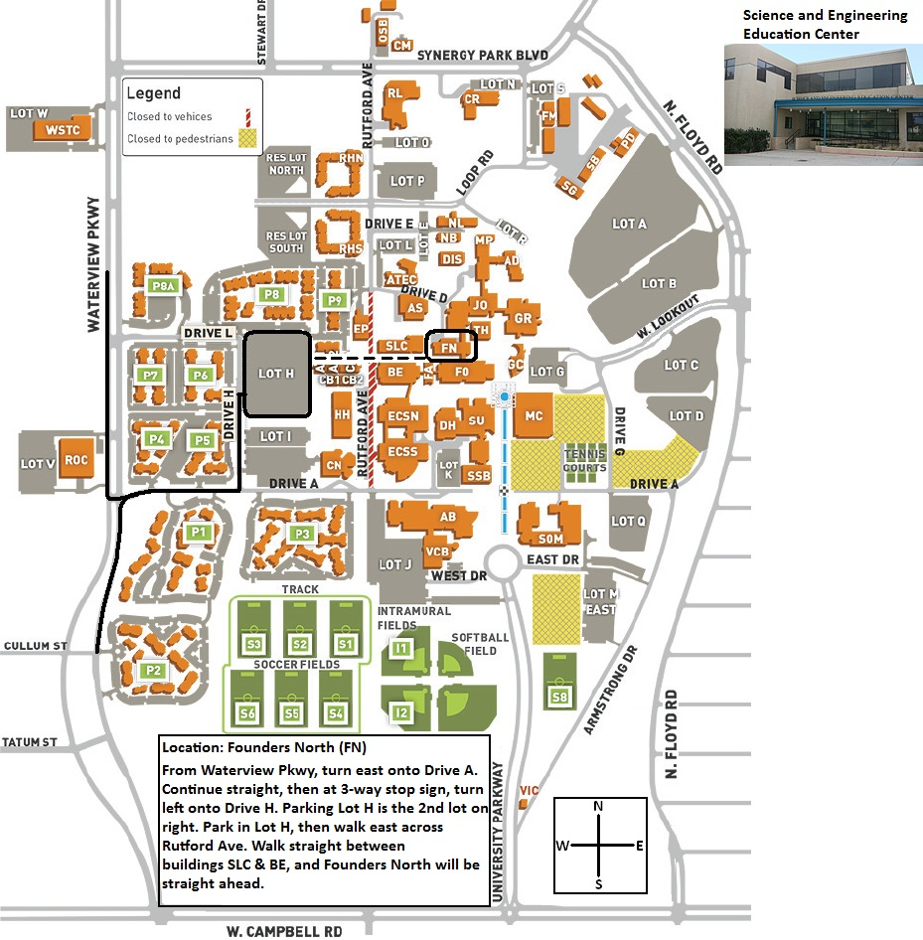
Map of the UT-Dallas campus
View of the north side of the Founders North Building. Enter this door. Elevator is to the left; go to 3rd floor. Room is just outside of elevator to the left.
800 W. Campbell Rd., Richardson, TX 75080
Park in Lot H

